**Detailed dataset information sheet**

|  |  |
| --- | --- |
| **Information Objective** | Assets and Environments |
| **Data Products** | Land Use Community Gardens |
| **Information Source / Model Product** | States: Environment; Google Maps, Earth and Search Engine |
| **Product Completion Progress** | In Progress |
| **Dataset / Metadata Document** | Australia - Community Gardens GDB  Community Gardens Metadata.pdf |
| **Dataset Use** | Surveillance Strategy and Design |

**Background**

A national point feature spatial dataset layer identifying community garden land use has been developed utilising publicly available information on Google Earth, Google Maps and associated search engine.

The initial facilities identified are those in close proximity to an Australian Port of Entry. These ports are listed in detail on the [Department of Home Affairs](https://www.homeaffairs.gov.au/trav/ente/avia/maritime/ports-of-entry) website.

**Initial Dataset Procurement Process**

The dataset has been derived by a number of manual processes:

* An initial search of the Google Earth and Google Maps engines with key words “community garden” was conducted
* Creation of a KML layer within Google Earth once suitable sites were confirmed visually from publicly available satellite and street view imagery
* Creation of a 2 kilometre buffer within ArcMap around the AA ports of entry which is then imported into Google Earth as a layer (Figure 1)
* Export of the final Google Earth KML layer to file
* Conversion of this layer within ArcMap using the KML to Layer (Conversion) tool to create and editable shapefile layer

Figure 1. Google Earth view of “community garden” search results and AA port of entry 2km buffer (orange circle)

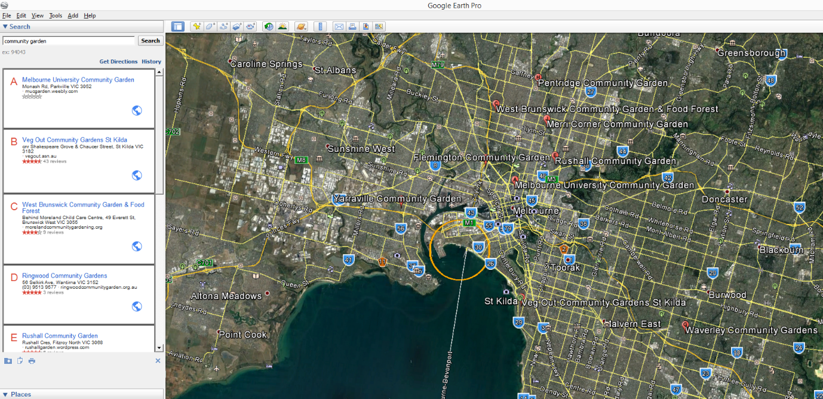

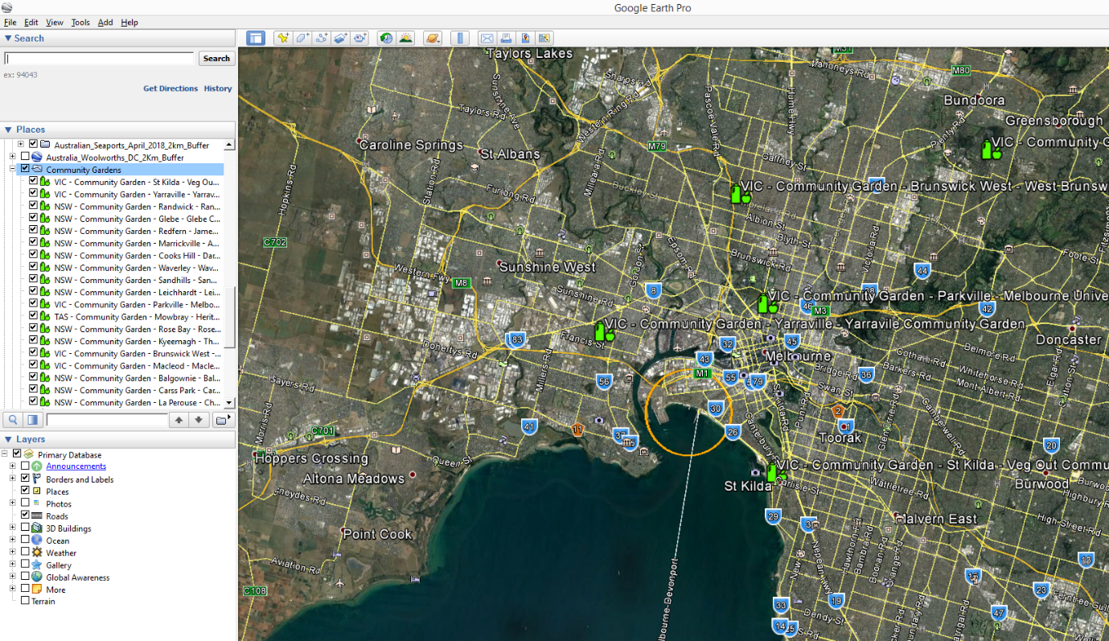Figure 2. Google Earth view of captured community garden locations” and AA port of entry 2km buffer (orange circle)

Figure 3. Google Earth close-up view of captured pallet storage yard facility

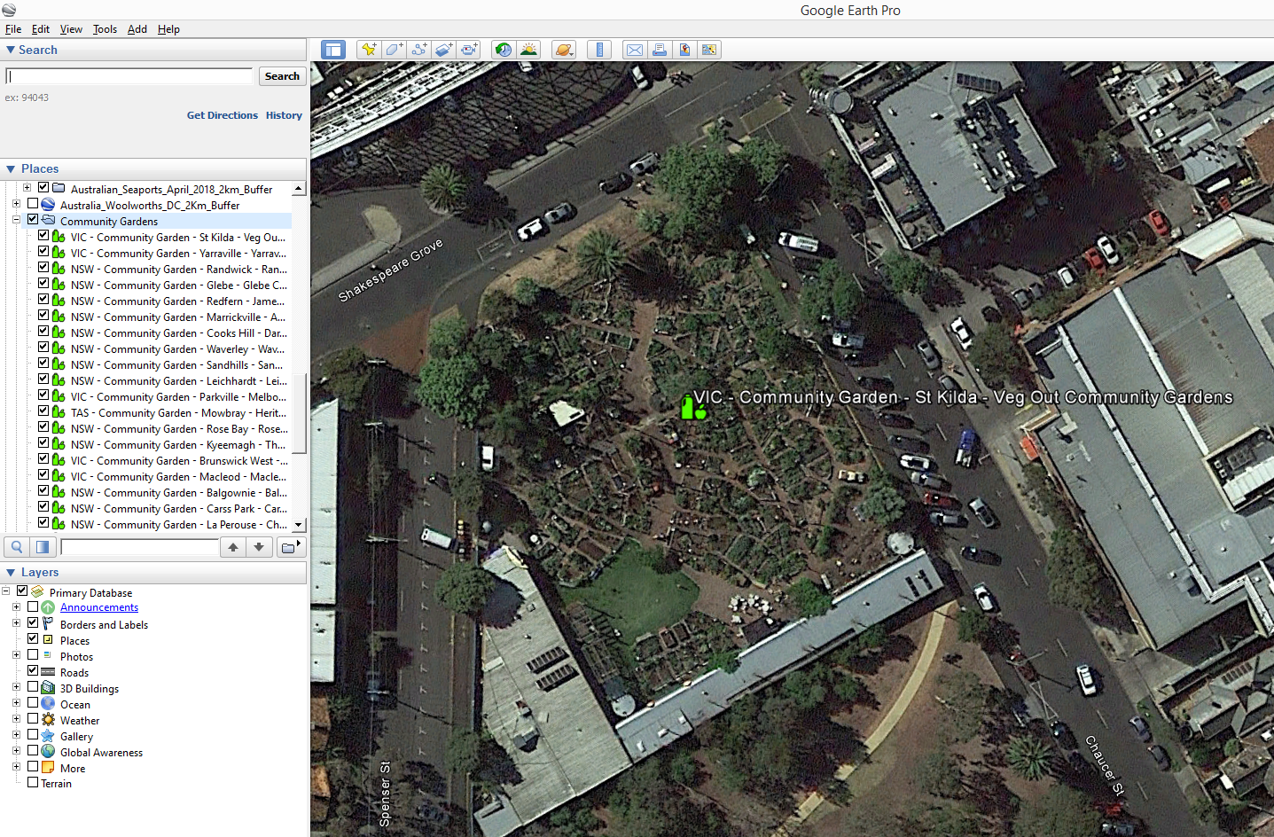

**In progress Dataset Procurement Processes**

Initially these sites were detected by chance in the process of compiling the Transport Hubs and Container Yards dataset.

This dataset may be useful for prioritising surveillance activities as the farming methods in these sites are generally organic.

These sites are also in a proximity zone to an AA port of entry that makes it reasonable for “escaped” pests to make their way to, unassisted or otherwise from these ports.

They also present a potential opportunity to collaborate with members of the public in a citizen scientist’s initiative for conducting surveillance and pest trapping and collection schemes.

**Limitations**

* None considered at this stage of the data procurement

**Quality Check**

* Nil conducted at this stage of the data procurement

Table 1. Summary of the datasets and their completion status to date

|  |  |  |  |  |
| --- | --- | --- | --- | --- |
|  | **Initial feature Count** | **Additional features detected** | **Estimated number of features to be captured** | **Estimated total feature count of completed dataset** |
| **Australia** | **33** | **-** | **50-100** | **~100** |

Discussion and Future Work

Future work may include quality assurance checks using ABS meshblock datasets of the appropriate land use category to identify other sites.

Expansion of the visual scanning zone to all built areas and/or smaller category appropriate ABS meshblocks in the areas around each AA port and within major capital city urban sprawl extents.

Capture of useful feature attributes such as:

* Type of plants grown
  + Will assist in determining surveillance options for specific pest groups based on host commodity material
* Farming practice e.g. Organic, use of pesticides, herbicides or fungicides
  + Assists in determining site suitability for targeting specific pest groups

Project Resources Estimates and Uses

An estimate of the timeframes and data procurement requirements required to complete this dataset is summarised in Table 2.

The end result will be a dataset product which is of a High to Authoritative quality and can be referenced as a point of truth data source for input into projects such as surveillance strategy and design.

This dataset will provide accurate and useful information such as:

* Community Garden facility locations
* Ownership and Contact information
* Area sizes
* Host material
* Farming practices for each site

And will assist in:

* Serving as an input in determining suitability of survey methods for pests such as those in the National Priority Plant Pests (NPPP) target groups, e.g.
* Mapping requirements for national/state emergency response programs that are deployed when these pest incursions occur as potential sites of first incursion and establishment
* Providing a feed-in data layer alongside the national road network for determining distribution pathways and the risk levels of these pathways

Table 2. Comparison of process methods and output dataset quality expectations

|  |  |  |  |  |
| --- | --- | --- | --- | --- |
| **Process** | **Requires Industry Assistance** | **Requires State Government Assistance** | **Estimated time to complete** | **Expected Dataset Quality Level** |
| 1 | No | No | ~ 1-2 weeks | High to Authoritative |